Phys 301 Assignment 5 Nicholas Pun

27872167

Q1. a), b) and c) respectively:

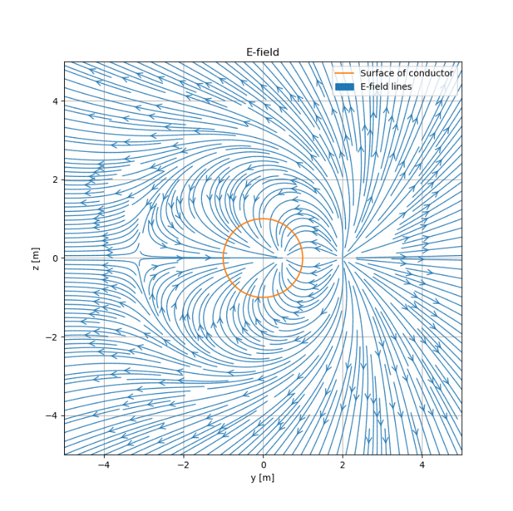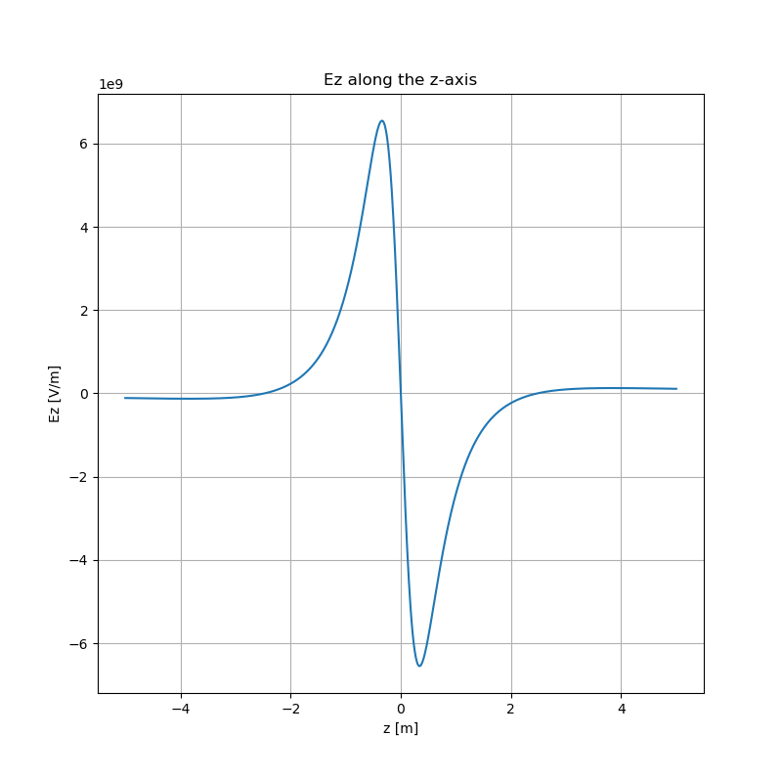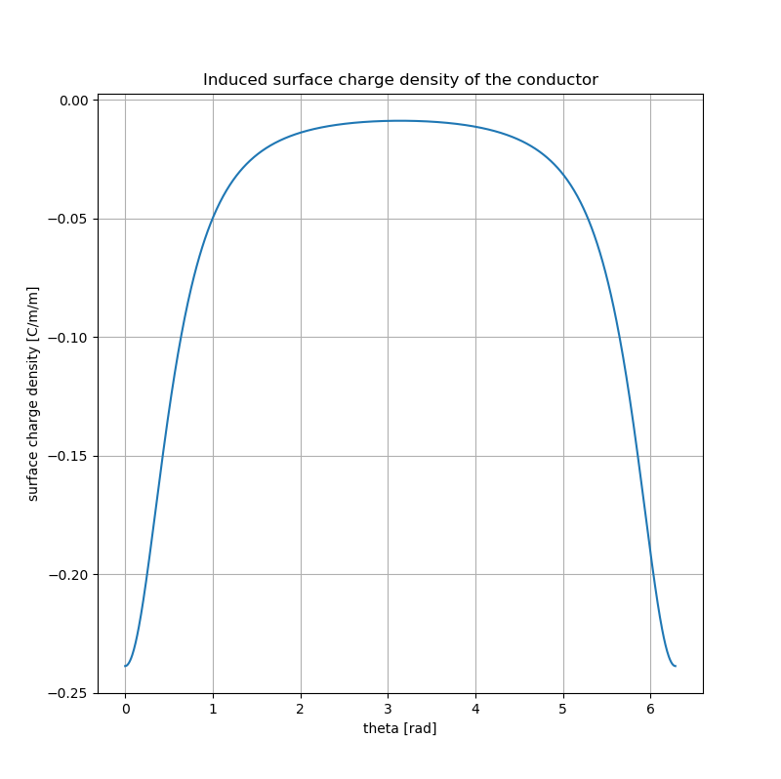

The code is as follows:

# -*- coding: utf-8 -*-

"""

Created on Tue Oct 15 09:03:29 2019

@author: Nick

"""

import numpy as np

import matplotlib.pyplot as plt

# Constants

eps0 = 8.854e-12

k = 1/(4*np.pi*eps0)

# Variables

a = 1

d = 2*a

b = a**3/d

q1 = 1

q2 = -q1*a/d

# Grid of y, z points

L=5*a

ny, nz = 1000, 1000

y = np.linspace(-L, L, ny)

z = np.linspace(-L, L, nz)

Y, Z = np.meshgrid(y,z)

# Electric Field

Ey = k*(q1*(-d+Y)*((-d+Y)**2+Z**2)**(-3/2) - q2*(b-Y)*((b-Y)**2+Z**2)**(-3/2))

Ez = k*(q1*Z*((-d+Y)**2+Z**2)**(-3/2) + q2*Z*((b-Y)**2+Z**2)**(-3/2))

# Create circle for surface of sphere

theta = np.linspace(0,2*np.pi,1000)

y1 = a*np.cos(theta)

z1 = a*np.sin(theta)

# Plot E-field

plt.figure(figsize = (8,8))

plt.streamplot(y, z, Ey, Ez, linewidth=1, density=3, arrowstyle='->', arrowsize=1.5);

plt.plot(y1,z1)

plt.xlabel('y [m]')

plt.ylabel('z [m]')

plt.title('E-field')

plt.legend(['Surface of conductor','E-field lines'])

plt.grid()

# Calculate Ez along z-axis

Ez1 = k*(q1*z*((-d)**2+z**2)**(-3/2) + q2*z*((b)**2+z**2)**(-3/2))

# Plot Ez

plt.figure(figsize = (8,8))

plt.plot(z,Ez1)

plt.xlabel('z [m]')

plt.ylabel('Ez [V/m]')

plt.title('Ez along the z-axis')

plt.grid()

# Calculate surface charge

sigma = eps0*k*(q1*(a-d*np.cos(theta))*(a**2+d**2-2*a*d*np.cos(theta))**(-3/2)

+ q2*(a-b*np.cos(theta))*(a**2+b**2-2*a*b*np.cos(theta))**(-3/2))

# Plot surface charge

plt.figure(figsize = (8,8))

plt.plot(theta,sigma)

plt.xlabel('theta [rad]')

plt.ylabel('surface charge density [C/m/m]')

plt.title('Induced surface charge density of the conductor')

plt.grid()